**Tic Tac Toe**

Functional requirement:

The game (Tic Tac Toe) is a game which can be played by either one player vs another player or one player vs one computer.

The game can have either a winner and a loser or it’s a tie game.

1. The system randomly chooses which player will start.

2. The player who get 3 ‘X’ or 3 ‘O’ consecutive wins.

3. The ‘X’ or ‘O’ can be in diagonal, horizontal or vertical.

4. The system should keep track that each user chooses only one free box and also checks if there is a winner each play.

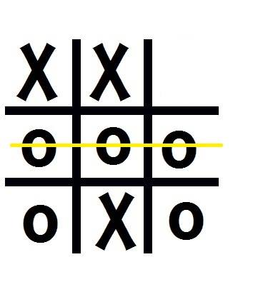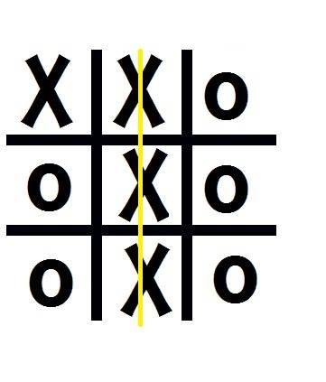

Figure 1: O wins Figure : X wins

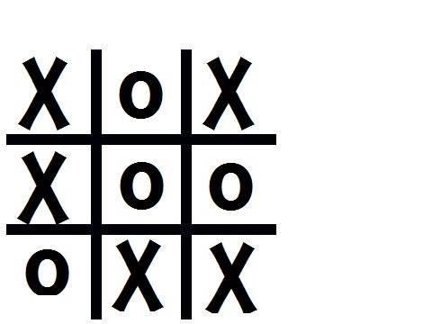

Figure 3: Draw­­

Non-functional requirement:

1.The game must be written in the development environment provided.

2.The game must take place in a single window, delivered on a computer.

3. There’s only 2 symbols to choose from either ‘X’ or ‘O’. (without single quote).

4. One player will be ‘X’ and one will be ‘O’. (without the single quote).

5. There’s only 9 boxes which the user will click and will either a ‘X’ or a ‘O’ will automatically appear.

6. The player should only click on free boxes.

7. Player 1 is always be ‘X’ and player 2 is always be ‘Y’.

8. Every round, the player who wins the first round, starts the next round.